**9 Virtues Dilemma**

**Keywords:**

**999=** **9Hours 9Persons 9Doors**

**VLR=** **Virtues Last Reward**

**ZTD=** **Zero Time Dilemma**

**Note:**

* **Before you play ZTD, please do play its prequels 999 and VLR to better understand the stories complex motives and the mechanics of the game.**
* **Also, please come to this guide when you have made the first decision in the game (which is made in the first 5 minutes of the game)**
* **Please follow these rules to avoid any minor spoilers.**

**Zero Escape: Zero Time Dilemma**

**Non-spoiler guide**

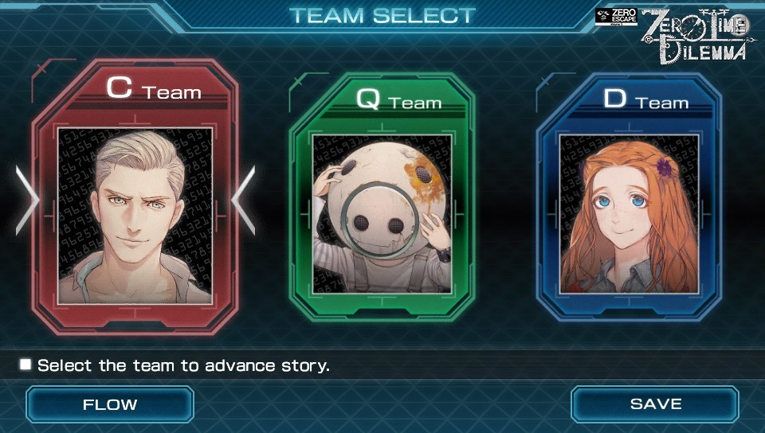

**Figure 1**

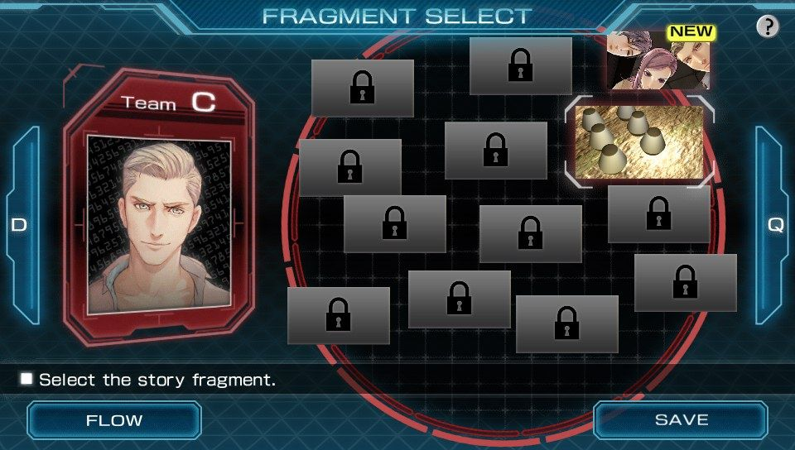

**Figure 2**

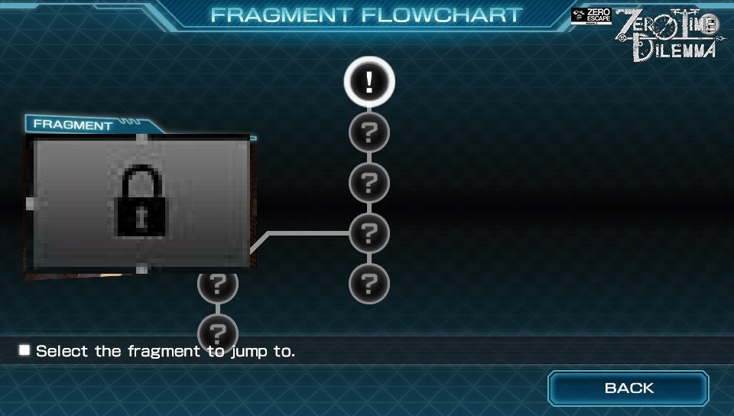

**Figure 3**

The story of ZTD is divided into three teams each team has its own fragments (refer to figure 1, 2 and 3) which will be used to complete the flowchart (refer to figure 4). Before we start please switch your flowchart to look like the one in VLR or the one in figure 3 to easily follow the story. Meaning the other flowchart type then the one shown in figure 4.

I used the fragment timeline not the complex one to explain the four different timelines and that one might lead to some spoilers.

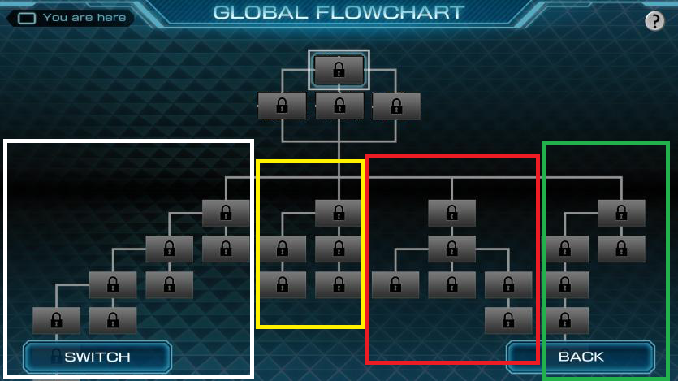

**Figure 4**

You should start with the 3rd timeline (red) and then when you have reached every lock go to the 4th timeline (green) then the 2nd timeline (yellow) and finally the 1st (white).

If you plan to complete one team’s fragments you will running across the timelines and won’t understand the story properly.

If you get stuck during the timeline be sure to check the global flowchart to see if there is exclamation mark if yes then play that part to unlock other fragments.

Now how to know which fragment is of which timeline here you need to do some work and check every fragment you have and match its shape with the shape of the flowchart. The shape of the fragments is a little weird so you will know which fragment goes where.

Also note down any key phrases or codes as they will be used by your other counterparts.

Lastly, I would like to say that this was my first guide and I will keep expanding and making it more user-friendly and this guide is not absolute so you can chose to play in your way whenever you like.

Credits:

[Kiritoxy](https://myanimelist.net/profile/KiritoXY)

[Genjutsuhh](https://myanimelist.net/profile/Genjutsuhh)